1.Architecture

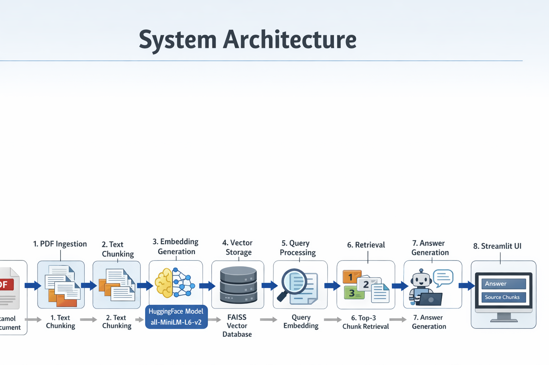The system is designed using a Retrieval-Augmented Generation (RAG) architecture, which combines information retrieval with language generation. The process begins with PDF ingestion, where the document is loaded and its text is extracted. This text is then preprocessed and split into smaller chunks for efficient handling. Each chunk is converted into embeddings and stored in a FAISS vector database.
When a user submits a query, the system converts the query into an embedding and retrieves the most relevant chunks from the database. These chunks are passed into a RetrievalQA chain, where a language model generates a response based on the provided context. The final output, including both the generated answer and source chunks, is displayed using a Streamlit interface, ensuring transparency and usability.
2.Chunking strategy

This splitter works by recursively breaking text based on a hierarchy of separators such as paragraphs, sentences, and characters. The goal is to maintain semantic coherence within each chunk while ensuring that the chunk size does not exceed model limits.
A typical configuration includes a chunk size of 500–1000 characters and a chunk overlap of 50–200 characters. The chunk size determines how much information each segment contains, while overlap ensures continuity between adjacent chunks. Without overlap, important information that spans across chunk boundaries might be lost, leading to incomplete or inaccurate answers.
The recursive splitting strategy prioritizes natural boundaries in the text, such as paragraph breaks, before resorting to smaller units like sentences or characters. This helps preserve the meaning and context of the original document.
Choosing the right chunking parameters is important. Smaller chunks improve retrieval precision but may lose context, while larger chunks preserve context but may reduce retrieval accuracy. Therefore, a balanced approach is required to optimize performance.
3.Embedding Concept
Embeddings are numerical vector representations of text that capture its semantic meaning. In this project, the all-MiniLM-L6-v2 model from Hugging Face is used to generate embeddings for each text chunk.
These embeddings enable the system to understand relationships between texts based on meaning rather than exact word matches. By using similarity measures like cosine similarity, the system can identify relevant content even if the query uses different wording. This makes embeddings a critical component of the RAG pipeline.
Retrieval process
The retrieval process is the core component that connects user queries with relevant document content. It ensures that the language model receives accurate and meaningful context for answer generation.
When a user inputs a query, the system first converts it into an embedding using the same model used for document chunks. This ensures consistency in the vector space representation.
The query vector is then compared with all stored vectors in the FAISS vector database. FAISS is optimized for fast similarity search, even with large datasets. It uses efficient indexing techniques to quickly identify the most relevant vectors.
The system retrieves the top-k most similar chunks (typically top 3). These chunks are considered the most relevant pieces of information for answering the query.
Once retrieved, these chunks are passed to a language model through a RetrievalQA chain. The model uses the provided context to generate an answer that is both accurate and grounded in the source material.
This approach significantly reduces hallucination, as the model relies on actual document content rather than generating responses purely from pre-trained knowledge.
Additionally, the system can display the retrieved chunks alongside the answer, improving transparency and allowing users to verify the source of the information.

